**Title** : Developing a Flight Delay Estimation Prediction Model Using Machine Learning

**Team ID :** PNT2022TMID15779

**Team Size :** 4

**Team Leader :** Notam Kedari

**Team member :** Peddamallu Sai Divyagr

**Team member :** Moneekha G

**Team member :** Nithya Sree P B

**Contents Discussed :**

**1.1 Access the resources (courses) in the project dashboard:** We are able to access all resources and courses which are required for the project Development from the website menu and our project has successfully approved by our college spoc.

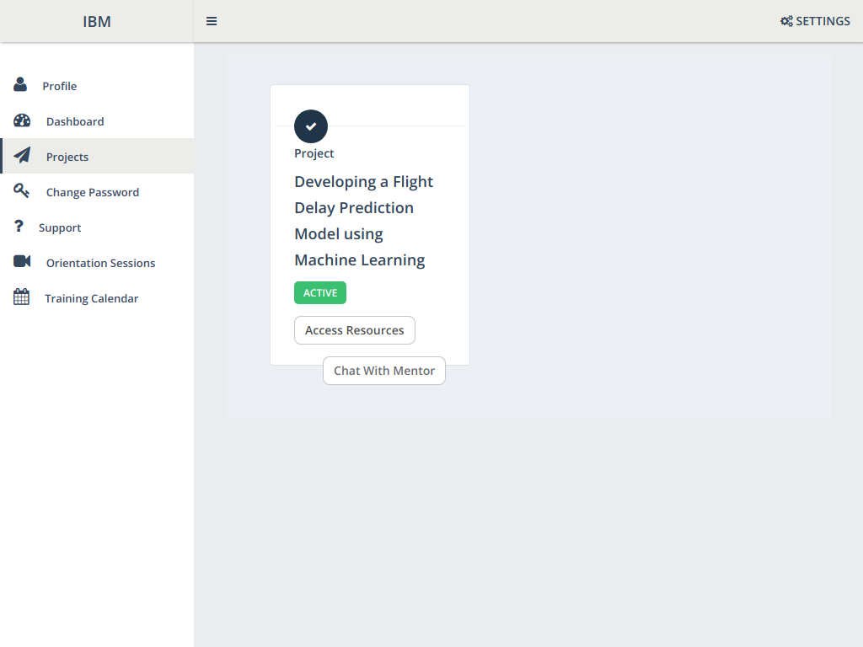

**1.2 Join the mentoring channel via platform & rocket-chat mobile app:** We have Downloaded Rocket-chat application and joined the respective project channel using the credentials.

**1.3 Access the guided project workspace:** The Pre-requisites,Project templates which are necessary for our project are installed.

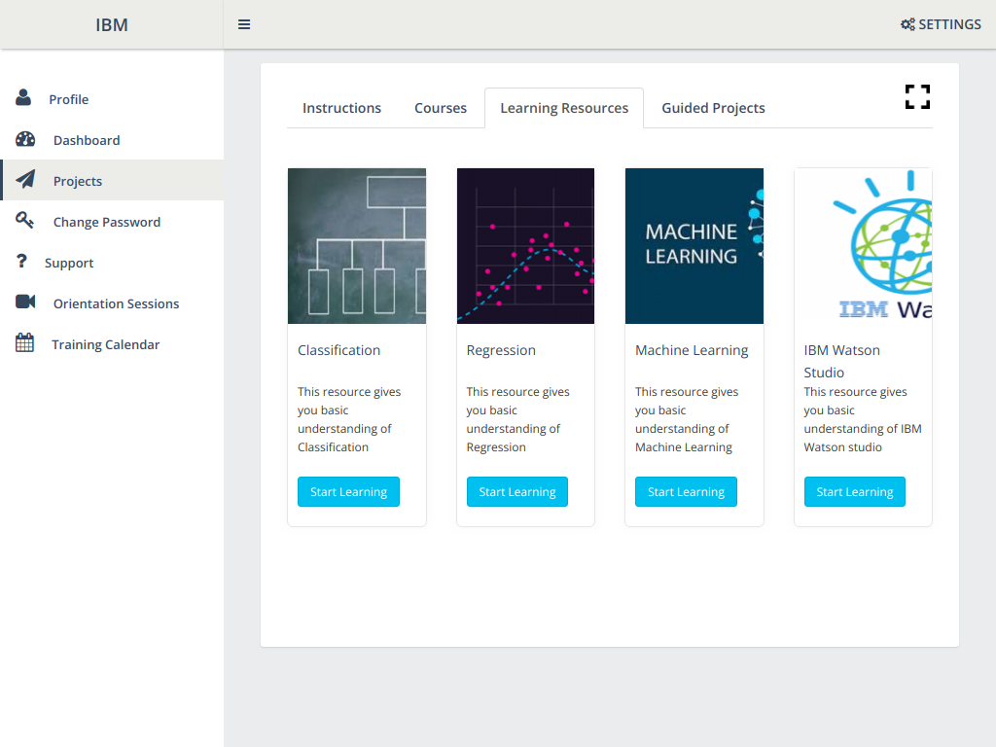

**1.4 Register on IBM Academic Initiative & Apply Feature code for IBM Cloud Credits:**We have Attended the sessions on IBM SkillsBuild, Registered on IBM SkillsBuild, applied feature code to receive credits for IBM Cloud, Started completing the skill badges.

**1.5 Create GitHub account & collaborate with Project Repository in project workspace:**Our Team Leader has Collaborated with git account by using activation mail and added remaining team members.

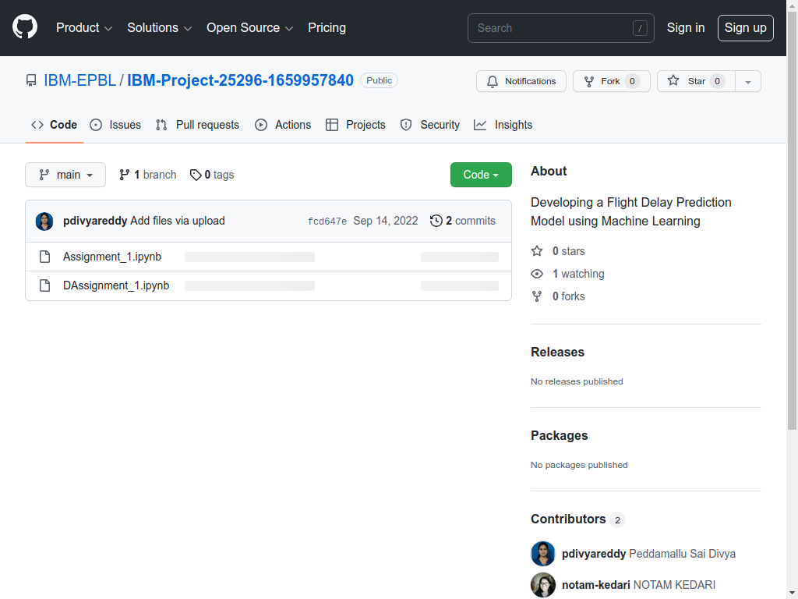

**1.6 Set-up the Laptop / Computers based on the prerequisites for each technology track :** Installed Anaconda Prompt, jupyter notebook IDE, spyder IDE required for developing our project.

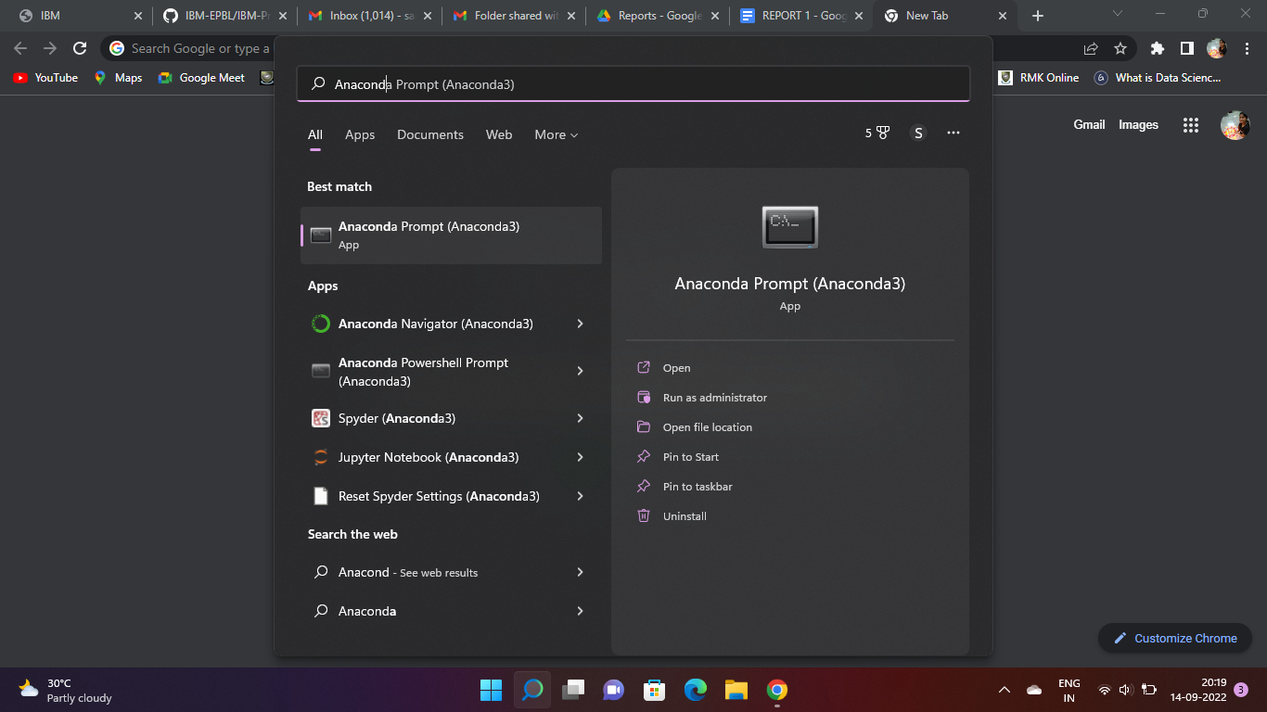

**Conclusion:**

Our Project - Developing a flight delay estimation prediction model using Machine Learning had been successfully approved by our college spoc. We have installed all the prerequisites for the project development and also collaborated successfully using a Git account.